ECE 443/543

Final Project

**General Guideline**

1. **Due on December 10, 11:59PM**
2. **For ECE 543 students, this is an individual project. For ECE 443 students, this is a two people project. For ECE 443 students, only one of your team members need to submit your work to Blackboard.**
3. **Late submission is not acceptable.**
4. **You need to submit your VHDL Workspaces and electronic version of your report via Blackboard (see the Section of Deliverable for details). You have to zip them into one file and clearly name and organize them.**
5. **For your report, you need to have one cover page to identify name, ECE 443 or ECE 533 student, and your team member (if applicable).**
6. **You need to put the comments to your code**

**ALDEC will be used, not Quartus.**

**Objective**

For the final project, you will be implementing a simple processor. The processor will support 7 different instructions, two instruction formats, support 256 half words of RAM (256 addresses by 16 bits) and have 8 registers. The following figure shows the high level overview of this processor.

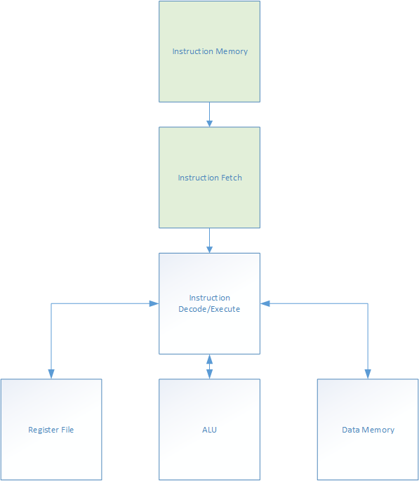

*High level overview of the processor*

For this lab, you will be implementing a processor. The basic design is a single cycle processor which implements the Instruction Decode/Execute, ALU, Register File and Data Memory sections. Each instruction is 16 bits wide. There are two formats, R-Type (register) and I-Type (immediate). Their formats are shown below. R-Type instructions perform an operation using the registers specified in a and b portions. The result is stored in the register specified by c portion. I-Type instructions specify an immediate value. In this project, the ldi instruction is the load immediate instruction. It loads the immediate value into the register specified by d portion. The sh and lh instructions store and load halfwords into the memory address specified by the immediate value.

|  |  |  |  |  |
| --- | --- | --- | --- | --- |
| R-Type | | | | |
| unused | opcode | c | a | b |
| 1 bit | 3 bits | 4 bits | 4 bits | 4 bits |

|  |  |  |  |
| --- | --- | --- | --- |
| I-Type | | | |
| unused | opcode | d | value |
| 1 bit | 3 bits | 4 bits | 8 bits |

The opcodes for the different instructions are specified below.

|  |  |  |  |  |  |
| --- | --- | --- | --- | --- | --- |
| S0 | S1 | S2 | Instruction Format | Operation | Mnemonic |
| 0 | 0 | 0 | R | Signed Addition | add |
| 0 | 0 | 1 | R | Signed Multiplication | mult |
| 0 | 1 | 0 | R | Passthrough A | pa |
| 0 | 1 | 1 | R | Passthrough B | pb |
| 1 | 0 | 0 | R | Signed Subtraction | sub |
| 1 | 0 | 1 | I | Load Immediate | ldi |
| 1 | 1 | 0 | I | Store halfword | sh |
| 1 | 1 | 1 | I | Load halfword | lh |

**Requirement:** Both theregister file and the RAM/memory can be implemented behaviorally using arrays. The instruction decode/execute is implemented using structural model.

Your processor should execute the following program.

ldi $r0, 10

ldi $r1, 5

ldi $r2, 0

ldi $r3, 0

ldi $r4, 0

ldi $r5, 0

ldi $r6, 0

ldi $r7, 0

add $r2, $r0, $r1

mult $r3, $r0, $r1

sub $r4, $r0, $r1

sh $r3, 0x0B

sh $r4, 0x0A

lh $r6, 0x0A

lh $r7, 0x0B

The following is the program compiled into hexadecimal.

500A

5105

5200

5300

5400

5500

5600

5700

0201

1301

4401

630B

640A

760A

770B

Here is the basic requirement for ALU. **This ALU must be implemented structurally using VHDL, expect for** multiplier**.** The ALU must take two 16-bit input arguments (A and B) and produce a 16-bit output argument (R). A, B and R are **signed** number. The instruction will be selected using three signal lines (S2, S1 and S0). There will also be a 3 bit status output (status). The status output is described in Table 2. Table 1 list the name of the I/O lines, their size and direction.

Table 1 – I/O Lines

|  |  |  |
| --- | --- | --- |
| Name | Direction | Size |
| A | I | 16 |
| B | I | 16 |
| R | O | 16 |
| S2 | I | 1 |
| S1 | I | 1 |
| S0 | I | 1 |
| status | O | 3 |

Table 2 – status output description

|  |  |
| --- | --- |
| Bit Position | Meaning when high |
| 2 | overflow condition |
| 1 | result is zero |
| 0 | result is negative |

The instruction set is shown in Table 3. All undefined operations should result in R being zero.

Table 3 - Opcodes

|  |  |  |  |
| --- | --- | --- | --- |
| S2 | S1 | S0 | Operation |
| 0 | 0 | 0 | Signed Addition |
| 0 | 0 | 1 | Signed Multiplication |
| 0 | 1 | 0 | Passthrough A |
| 0 | 1 | 1 | Passthrough B |
| 1 | 0 | 0 | Signed Subtraction |
| 1 | 0 | 1 | Undefined |
| 1 | 1 | X | Undefined |

You must show that all of the parts of the ALU (adder, subtractor, multiplier and multiplexer) and the ALU itself work by showing the functional simulation diagrams. You should come up and show enough test cases to prove that it is working. For example, if you were testing the adder you could do 2+2, 2+(-2) and (-2)+(-2).

Hint:

The multiplexer should be an 8-input multiplexer. This selects the correct output for the instruction and there are 5 possible outputs.

This ALU works by executing all instructions at the same time. This means that no matter what the op-code is, it adds and multiplies the numbers. Take for instance this example where we have two 4-bit inputs and a 4-bit output.

    R1[0 .. 3] = add(A, B);

    R2[0 .. 3] = mult(A, B);

 R1 is the result of the addition of A and B. R2 is the result of the multiplication of A and B. If we want the output to be R, we can use a multiplexer to select the correct output. If the op-code is determined by S where if S = 0, the output is R1 and if S = 1, the output is R2.

   Multiplexer(R1(0), R2(0), S, R(0))

   Multiplexer(R1(1), R2(1), S, R(1))

   Multiplexer(R1(2), R2(2), S, R(2))

   Multiplexer(R1(3), R2(3), S, R(3))

  The multiplier should multiply two 16-bit numbers. That means that the result could require 32 bits. In order to take care of this problem, the status register should indicate an overflow condition if the result is greater than 16 bits.

In this project, the propagation delay for logic gates in ALU needs to be taken into consideration. Please assign 10 ns for each logic operation, AND, OR, NOT,…etc, as the propagation delay so that you can estimate how long it will take for the arithmetic operations. However, the multiplexer will be considered to work ideally without having propagation delay.

**Grading/Deliverables**

**Screenshots must be readable!**

* Implement the ALU (15 pts). Generate a testbench and show that it works for addition, subtraction, multiplication, passthrough A and passthrough B by including screenshots. In the report, you also need to explain how you design your ALU, such as, circuit, etc.
* Implement the 8 x 16 bit register file (15 pts). Generate a testbench and show that you can store and retrieve 16 bit values. Generate a testbench and show that it works using a readable screenshot. In the report, you also need to explain how you design your register file.
* Implement the instruction decoder (15 pts). Generate a testbench which shows it operating and include a readable screenshot. In the report, you also need to explain how you design your instruction decoder, such as circuit, etc.
* Implement the 256 address x 16 bit RAM (20 pts). Generate a testbench and show that you can store and retrieve values from it. Include a screenshot. In the report, you also need to explain how you design your RAM.
* Show the processor works (20 pts). Generate a testbench to run the above program. At the end of the program, what are the values in $r6 and $r7? Write these values in your lab report.
* Implement the instruction memory and instruction fetch cycle (15 pts). Generate a testbench and show that it works by using a screenshot.
* Answer following questions for ALU using 16 bit adder, 16 bit multiplier, 16 bit multiplexer and gates
  + - How long does it take to add 1000 to 2000? You should show the timing diagram and explain it.
    - How long does it take to multiply 128 * 128? Show the timing diagram* and explain it.
    - Using the results from1 and 2, how many additions and multiplications per second can your ALU perform?
    - Describe some ways that you could optimize the design to make it faster.

The deliverables for this lab are the report and the code. Your code should be put into a zip file and sent to the instructor.